

AP® Physics C
1988 Free response Questions

The materials included in these files are intended for use by AP teachers for course and exam preparation in the classroom; permission for any other use must be sought from the Advanced Placement Program®. Teachers may reproduce them, in whole or in part, in limited quantities, for face-to-face teaching purposes but may not mass distribute the materials, electronically or otherwise. These materials and any copies made of them may not be resold, and the copyright notices must be retained as they appear here. This permission does not apply to any third-party copyrights contained herein.

These materials were produced by Educational Testing Service® (ETS®), which develops and administers the examinations of the Advanced Placement
Program for the College Board. The College Board and Educational Testing Service (ETS) are dedicated to the principle of equal opportunity, and their
programs, services, and employment policies are guided by that principle.

The College Board is a national nonprofit membership association dedicated to preparing, inspiring, and connecting students to college and opportunity.
Founded in 1900, the association is composed of more than 4,200 schools, colleges, universities, and other educational organizations. Each year, the
College Board serves over three million students and their parents, 22,000 high schools, and 3,500 colleges, through major programs and services in
college admission, guidance, assessment, financial aid, enrollment, and teaching and learning. Among its best-known programs are the SAT®, the
PSAT/NMSQT®, and the Advanced Placement Program® (AP®). The College Board is committed to the principles of equity and
excellence, and that commitment is embodied in all of its programs, services, activities, and concerns.

APIEL is a trademark owned by the College Entrance Examination Board. PSAT/NMSQT is a registered trademark jointly owned by the College Entrance Examination Board and the National Merit Scholarship Corporation. Educational Testing Service and ETS are registered trademarks of Educational Testing Service.
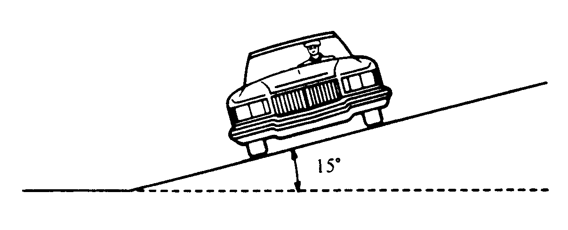
1988M1. A highway curve that has a radius of curvature of 100 meters is banked at an angle of 15° as shown above.
a. Determine the vehicle speed for which this curve is appropriate if there is no friction between the road and the tires of the vehicle.

On a dry day when friction is present, an automobile successfully negotiates the curve at a speed of 25 m/s.
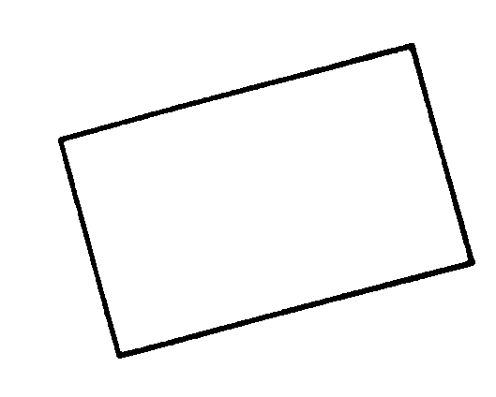
b. On the diagram below, in which the block represents the automobile, draw and label all of the forces on the automobile.
c. Determine the minimum value of the coefficient of friction necessary to keep this automobile from sliding as it goes around the curve.
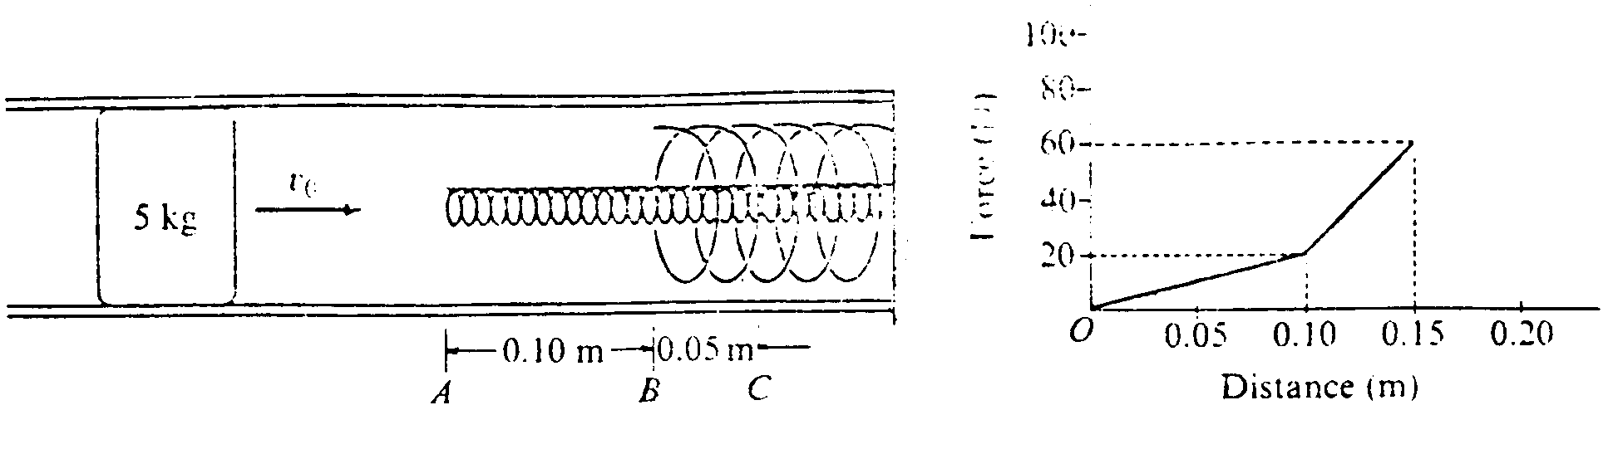
1988M2. A 5-kilogram object initially slides with speed v_{o} in a hollow frictionless pipe. The end of the pipe contains two springs. one nested inside the other, as shown above. The object makes contact with the inner spring at point A, moves 0.1 meter to make contact with the outer spring at point B, and then moves an additional 0.05 meter before coming to rest at point C. The graph shows the magnitude of the force exerted on the object by the springs as a function of the objects distance from point A.
a. Calculate the spring constant for the inner spring.
b. Calculate the decrees in kinetic energy of the object as it moves from point A to point B.
c. Calculate the additional decrease in kinetic energy of the object as it moves from point B to point C.
d. Calculate the initial speed v_{o} of the object
e. Calculate the spring constant of the outer spring

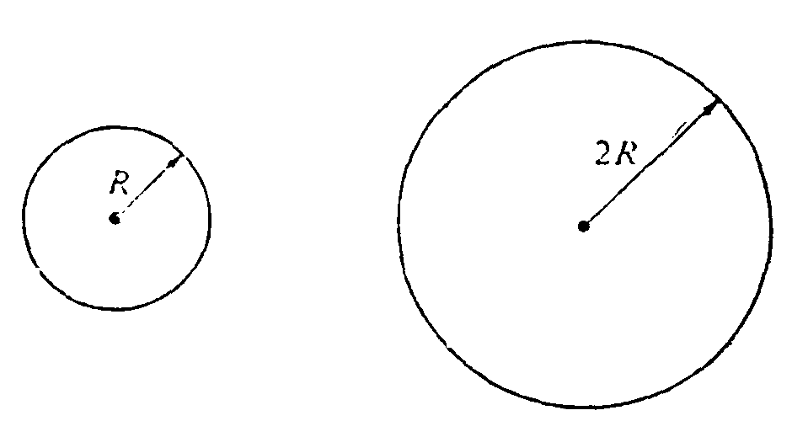
1988M3. The two uniform disks shown above have equal mass, and each can rotate on frictionless bearings about a fixed axis through its center. The smaller disk has a radius R and moment of inertia I about its axis. The larger disk has a radius 2R
a. Determine the moment of inertia of the larger disk about its axis in terms of I.

The two disks are then linked as shown below by a light chain that cannot slip. They are at rest when, at time t = 0, a student applies a torque to the smaller disk, and it rotates counterclockwise with constant angular acceleration α. Assume that the mass of the chain and the tension in the lower part of the chain, are negligible. In terms of I, R, α, and t, determine each of the following:

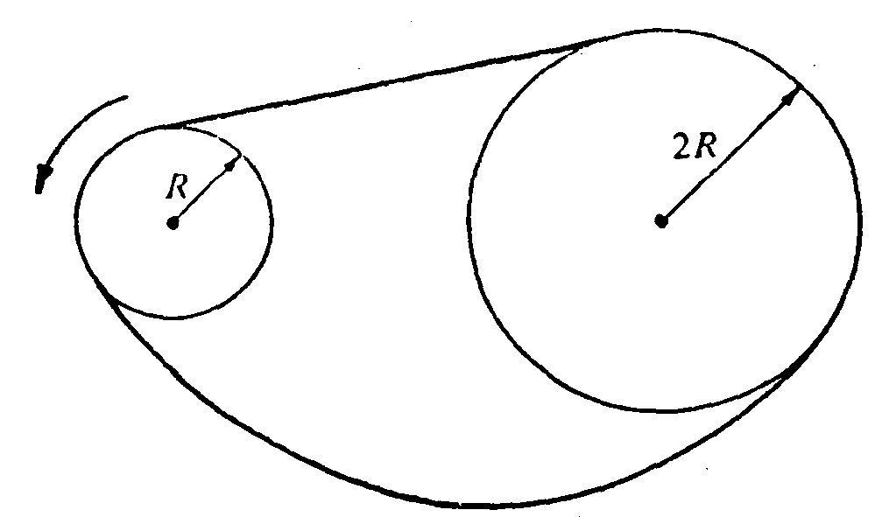
b. The angular acceleration of the larger disk
c. The tension in the upper part of the chain
d. The torque that the student applied to the smaller disk
e. The rotational kinetic energy of the smaller disk as a function of time

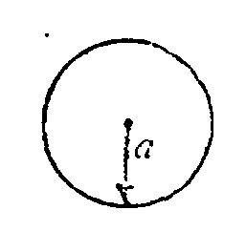
1988E1. The isolated conducting solid sphere of radius a shown above is charged to a potential V.
a. Determine the charge on the sphere.
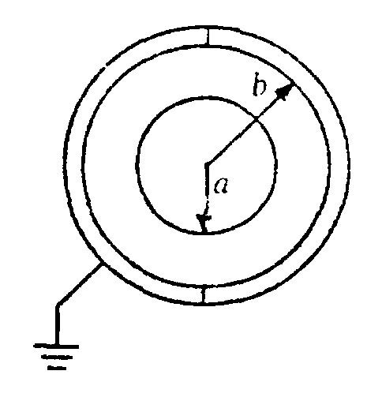
Two conducting hemispherical shells of inner radius b are then brought up and, without contacting the solid sphere are connected to form a spherical shell surrounding and concentric with the solid sphere as shown below The outer shell is then grounded.
b. By means of Gauss's law, determine the electric field in the space between the solid sphere and the shell at a distance r from the center.
c. Determine the potential of the solid sphere relative to ground.
d. Determine the capacitance of the system in terms of the given quantities and fundamental constants.
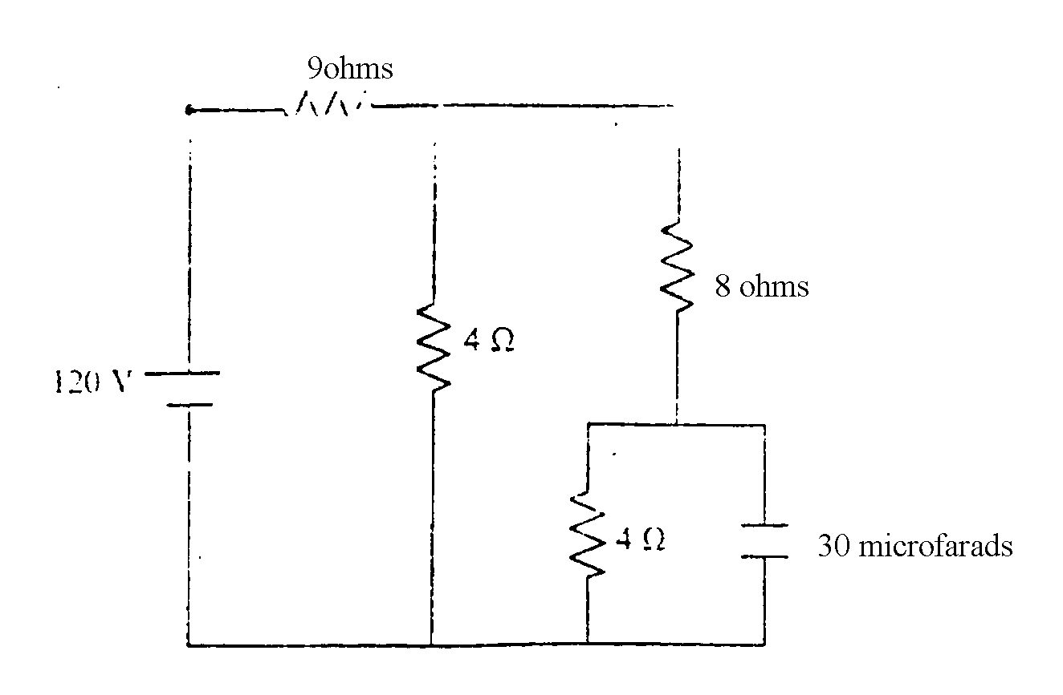
P
1988E2. In the circuit shown above. the battery has been connected for a long time so that the currents have steady values. Given these conditions, calculate each of the following
a. The current in the 9-ohm resistor.
b. The current in the 8-ohm resistor.
c. The potential difference across the 30-microfarad capacitor.
d. The energy stored in the 30-microfarad capacitor.

At some instant, the connection at point P fails, and the current in the 9-ohm resistor becomes zero.
e. Calculate the total amount of energy dissipated in the 8-ohm resistor after the connection fails.
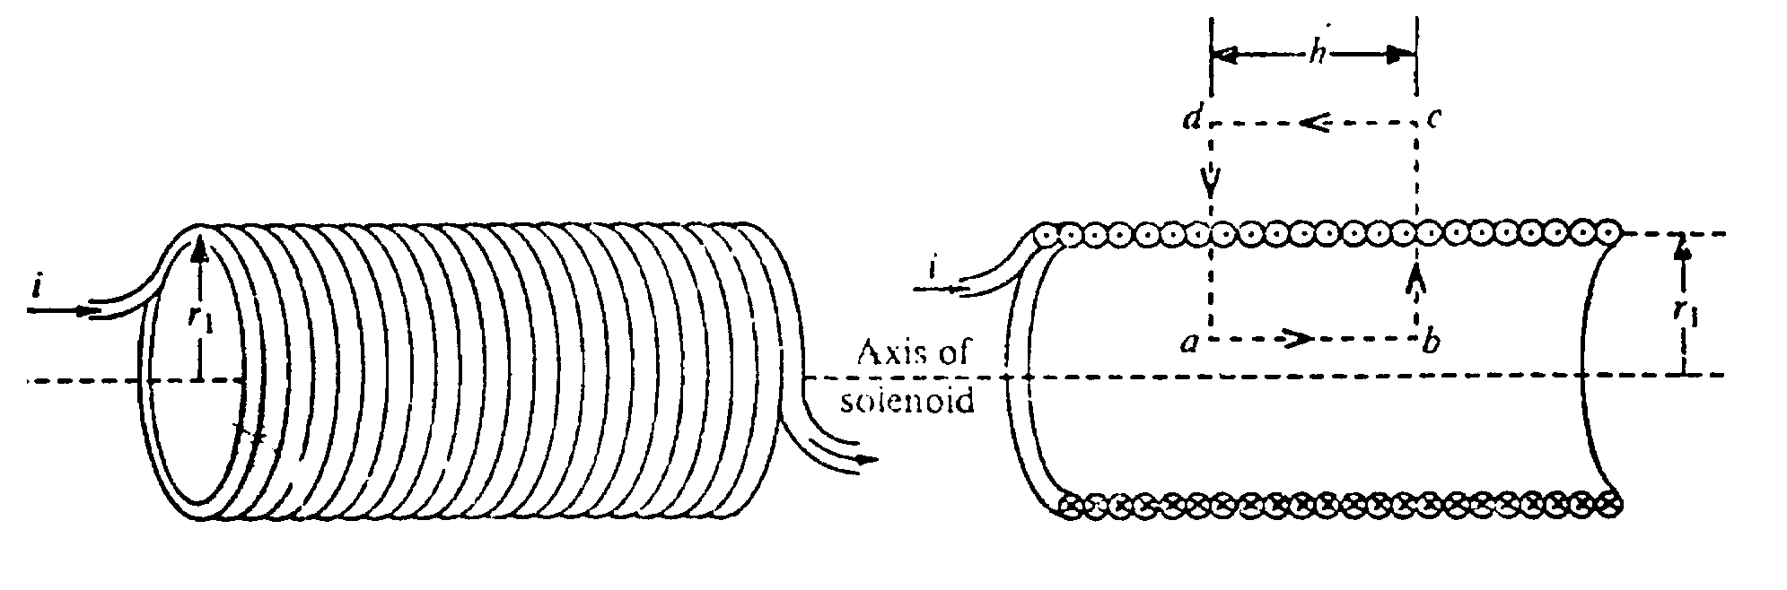
1988E3. The long solenoid shown in the left-hand figure above has radius r₁ and n turns of wire per unit length, and it carries a current i. The magnetic field outside the solenoid is negligible.
a. Apply Ampere's law using the path abcda indicated in the cross section shown in the righthand figure above to derive an expression for the magnitude of the magnetic field B near the center of the solenoid
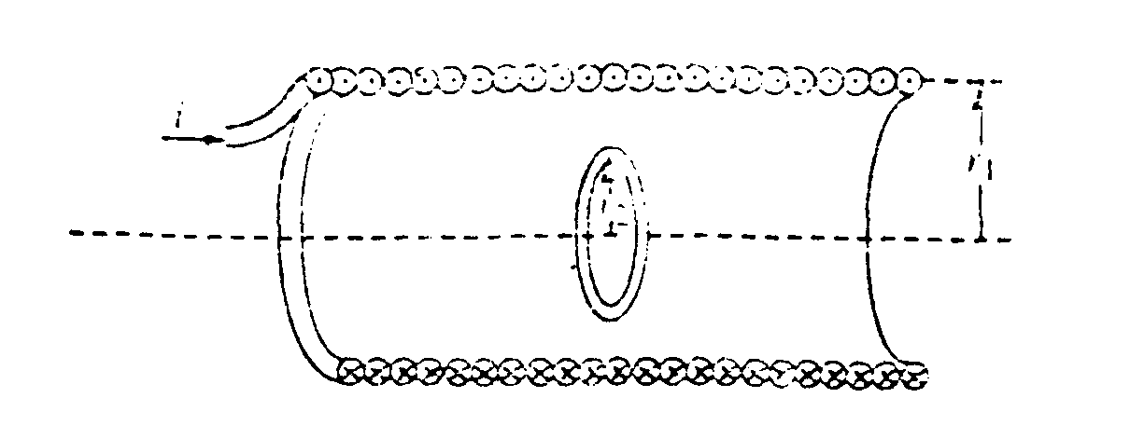
A loop of radius r₂ is then placed at the center of the solenoid, so that the plane of the loop is perpendicular to the axis of the solenoid, as shown above. The current in the solenoid is decreased at a steady rate from i to zero in time t. In terms of the given quantities and fundamental constants, determine:
b. The emf induced in the loop.
c. The magnitude of the induced electric field at a point in the loop.

The loop is now removed and another loop of radius r₃ is placed outside the solenoid, so that the plane of the loop is perpendicular to the axis of the solenoid, as shown above. The current in the solenoid is again decreased at a steady rate from i to zero in time t. In terms of the given quantities and fundamental constants, determine:
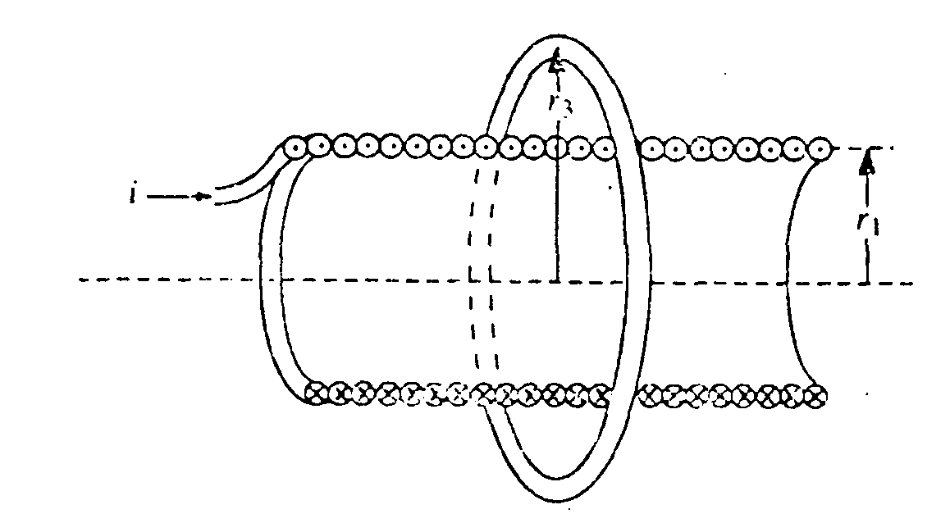
d. The emf induced in the loop.
e. The magnitude of the induced electric field at a point in the loop.

